Use if terminal npm not working (set-executionpolicy remotesigned -scope currentuser)

**Step 1: Set Up the Project**

Open **VS Code** and follow these steps:

1. **Open Terminal** and run:

npm create vite@latest ecom-product-page

1. Choose the following options:
   * **Framework**: React
   * **Variant**: JavaScript
2. Navigate into the project:

cd ecom-product-page

1. Install dependencies:

npm install

1. Start the development server:

npm run dev

**Step 2: Project Structure**

Inside src/, create the following component files:

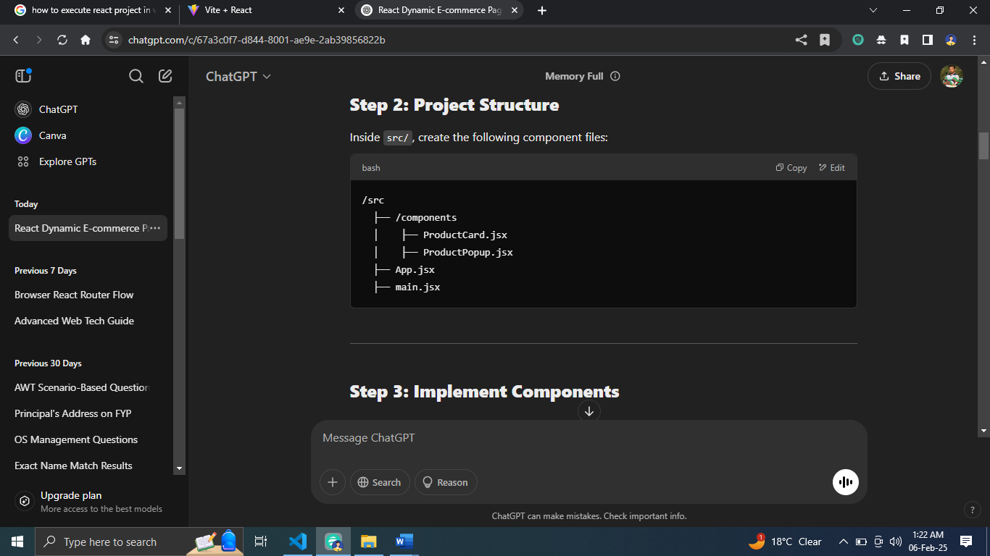

**Step 3: Implement Components**

**1. ProductCard.jsx (Displays Product & Handles Availability)**

import React, { useState } from "react";

import ProductPopup from "./ProductPopup";

const ProductCard = ({ product }) => {

const [available, setAvailable] = useState(product.inStock);

const [showPopup, setShowPopup] = useState(false);

const toggleAvailability = () => {

setAvailable(!available);

};

return (

<div className="product-card">

<img src={product.image} alt={product.name} />

<h2>{product.name}</h2>

<p>Price: ₹{product.price}</p>

<p>Status: {available ? "In Stock" : "Out of Stock"}</p>

<button onClick={toggleAvailability}>

{available ? "Mark Out of Stock" : "Mark In Stock"}

</button>

<button onClick={() => setShowPopup(true)}>View Details</button>

{showPopup && <ProductPopup product={product} closePopup={() => setShowPopup(false)} />}

</div>

);

};

export default ProductCard;

**2. ProductPopup.jsx (Pop-up Component for Product Details)**

import React from "react";

const ProductPopup = ({ product, closePopup }) => {

return (

<div className="popup-overlay">

<div className="popup-content">

<h2>{product.name}</h2>

<img src={product.image} alt={product.name} />

<p>{product.description}</p>

<p>Price: ₹{product.price}</p>

<button onClick={closePopup}>Close</button>

</div>

</div>

);

};

export default ProductPopup;

**3. App.jsx (Main Component with Product Data)**

import React from "react";

import ProductCard from "./components/ProductCard";

const productData = {

name: "Smartphone XYZ",

price: 19999,

inStock: true,

image: "https://via.placeholder.com/150",

description: "A high-performance smartphone with an amazing display and camera."

};

const App = () => {

return (

<div className="app">

<h1>Dynamic E-commerce Product Page</h1>

<ProductCard product={productData} />

</div>

);

};

export default App;

**4. main.jsx (Entry Point)**

import React from "react";

import ReactDOM from "react-dom/client";

import App from "./App";

import "./index.css";

ReactDOM.createRoot(document.getElementById("root")).render(

<React.StrictMode>

<App />

</React.StrictMode>

);

**Step 4: Add CSS (Style the Page)**

**Inside src/index.css, add styles:**

.app {

text-align: center;

font-family: Arial, sans-serif;

}

.product-card {

border: 1px solid #ddd;

padding: 20px;

width: 300px;

margin: auto;

border-radius: 8px;

text-align: center;

box-shadow: 2px 2px 10px rgba(0, 0, 0, 0.1);

}

.product-card img {

width: 100%;

height: auto;

border-radius: 5px;

}

button {

margin: 10px;

padding: 10px;

border: none;

cursor: pointer;

background-color: #007bff;

color: white;

border-radius: 5px;

}

button:hover {

background-color: #0056b3;

}

.popup-overlay {

position: fixed;

top: 0;

left: 0;

width: 100%;

height: 100%;

background: rgba(0, 0, 0, 0.5);

display: flex;

justify-content: center;

align-items: center;

}

.popup-content {

background: white;

padding: 20px;

border-radius: 8px;

text-align: center;

width: 300px;

}

**Step 5: Run the Project**

1. Start the project:

npm run dev

1. Open **http://localhost:5173/** in the browser.

**Expected Functionality**

* The **Product Card** displays:
  + Name
  + Price
  + Availability status
  + Image
  + Buttons to toggle stock status and open a pop-up.
* Clicking **"View Details"** shows a **pop-up** with the product details.
* Clicking **"Mark Out of Stock"** toggles the stock status.